Date/Time | Monday 26th October  2020 | Tuesday 27th October 2020 | Wednesday 28th October 2020 | Thursday 29th October  2020 | Friday 30th October
Breakfast  8:00am-9:00am | Coffee Filter Bats | Leaf Crown Creating | Autumn Colouring Sheets. | Scented Playdough. | Leaf Coaster Decorating
Morning  9:00am-12:00pm | Pom Pom Acorn Creating | Colourful Spider Webs | Autumn Lantern Making | Rice Krispies Pumpkin | Puzzle Tree Creating
Lunch  12:00pm-1:00pm | Lunchtime | Lunchtime | Lunchtime | Lunchtime | Lunchtime
Afternoon  1:00pm-4:00pm | Chocolate Apple Slices | 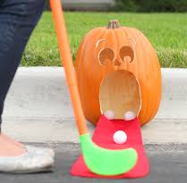  Pumpkin Crazy Golf. | Autumn Whirligigs | 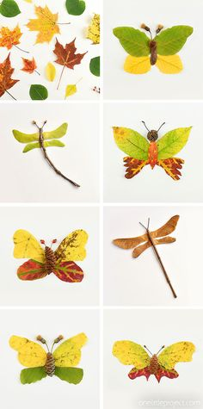  Autumn Leaf Butterflies | Mandarin Pumpkins
Twilight  4:00pm-6:00pm | Pebble Hedgehog Decorating | Pipe cleaner bead pumpkins | Leaf Sun Catchers | Hotel Transylvania Movie and Rainbow-Drops | Spooky Mask Making
October Holiday Club 2020 – East Site

